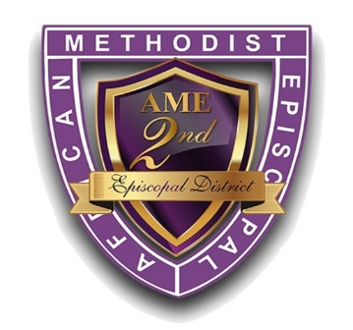
African Methodist Episcopal Church
Second Episcopal District
The Valerie Faith Gary Bell Dedication
Celebration Souvenir Journal/Sponsorship

Advertising Space Order Form

RATES: | Full Page – $150.00 | Half Page – $75.00 | Quarter Page – $50.00
 | Front Inside Cover - $500.00 | Back Inside Cover - $500.00
 | Bronze Sponsor - $1,000.00  - Name listed in the Dedication program book  - Video space in the Digital Journal that will play throughout the meeting | Silver Sponsor - $1,500.00  - Same as Bronze plus  - ½ page ad in the digital journal book | Platinum Sponsor - $3,000.00  - Same as Gold plus  - Recognition during the 3-day meeting
Gold Sponsor - $2,500.00
- Same as Silver plus
- 1 full page ad in the digital journal

SPECIFICATIONS: |  | Full Page Ads have a maximum image area of 8½” wide by 11” high.  Half Page Ads have a maximum image area of 8½” wide by 5½ high.  Quarter Page Ads have a maximum image area of 4¼” wide by 5½” high.
FORMAT: | Please submit all ads electronically via DropBox using this link: https://www.dropbox.com/request/kQuHZlki4J8YaWJLjWoQ  Ads must be camera ready. We will accept the following file formats: JPG, JPEG, or PDF

ALL ADVERTISEMENTS MUST BE PREPAID AND RECEIVED
NO LATER THAN FEBRUARY 6, 2023

Please make checks or money orders payable to the SECOND EPISCOPAL DISTRICT

Purchaser’s Name_________________________________________________________________________

Address_________________________________________________________________________________

Phone #________________________________ Email Address__________________________________

RETURN FORM WITH PAYMENT TO: | Baltimore Conference  Bethlehem AME Church – Attn: Rev. Dr. Maryetta Ramsey  6616 Graceland Avenue, Baltimore, MD 21224  Washington Conference; Outside the District Ads & Sponsorships  Turner Memorial AME Church – Attn: Dr. D.K. Kearney  7201 16th Place, Hyattsville, MD 20783  Virginia Conference: St. John’s AME Church – Attn: Rev. Christian Savage  545 E. Bute Street, Norfolk, VA 23510  North Carolina Conference  Mr. Elbert Davis 19 June Lane, Enfield, NC 27823  Western North Carolina Conference: St. Joseph AME Church – Attn: Ms. Azzie Conley  2521 Fayetteville Street, Durham, NC 27707

Authorized signature of purchaser______________________________________ Date: ________________

Questions, comments, concerns, contact: churchame2@gmail.com

